Window lifter
SW Component MPC5606B

Revision History
Issue status  (Index) | Maturity/Date  (draft/invalid/valid)  (dd-mmm-yyyy) | Author  Department | Check/Release  Department | Description
1.0 | Draft  04-0ct-09 | Miguel Garcia | Miguel Garcia | Creation of the document
2.0 | Draft  27-Oct-15 | José Luis Martínez Vicuña | Jorge Luis Gomez Gonzalez | Redaction the 1, 2, 3 and 4 chapters.
2.1 | Draft  29-Oct-15 | Jorge Luis Gomez Gonzalez | José Luis Martínez Vicuña | Were added some diagrams and some corrections
2.2 | Draft  30-Oct-15 | José Luis Martínez Vicuña | Jorge Luis Gomez Gonzalez | Were added changes to chapter 4
2.3 | Draft  31-Oct-15 | José Luis Martínez Vicuña | Jorge Luis Gomez Gonzalez | Were added new changes to chapter 4
2.4 | Draft  31-Oct-15 | Jorge Luis Gomez Gonzalez | José Luis Martínez Vicuña | Were added function diagrams chapter 5

Table of Contents
1 Purpose 3
2 Definitions and abbreviations 3
3 Realization constraints and targets 3
4 SW Conceptual design 3
5 SW Component internal breakdown 4
5.1 Functional Decomposition 4
5.2 Function <Type> <function name> (type par 1, .., type par n) 5
5.3 Function <Type> <function name> (type par 1, .., type par n) 5

Purpose
The purpose is control the window movement with a module controlled by two switches that indicate the direction of the window.
This control is simulated with leds.

Definitions and abbreviations

Definitions
rul_TimeMsCnt | Long that counts milliseconds to validate the 10 milliseconds | 0…10
rul_TimeWait | Long that counts milliseconds to validate the 5 seconds wait after an antipinch | 0…5000
rub_ValidAntipinchCnt | Long that counts milliseconds to validate the 10 milliseconds (for an antipinch) | 0…10
rul_TimeTransition | Long that counts milliseconds | 0…400
rub_ValidPress | Boolean that indicates if is valid de button press | True/False
rub_CmdWindow | Byte that indicates how long a button has been pressed | Long/Short/No
rub_ButtonPressed | Byte that indicates if the button has been pressed | NoPress/Press
rub_AntipinchButton | Byte that indicates if the button antipinch has been pressed | NoPress/Press
rub_DirectionMove | Byte that indicates the direction of the window | Up, Down, No
rub_StateWin | Byte that indicates the status of the window | 0…10
rub_DirectionIndicador | Byte that indicates the LED that must turn on | Green/Blue/Off all

Abbreviations
msec milliseconds
MCU Microcontroller
GPIO General-Purpose input/output
MC_ME Mode Entry Module
SIUL System Integration Unit Lite
STM System Timer Module
HAL Hardware Abstraction Layer
MAL Middleware Abstraction Layer

References
N° | Document name | Reference
1 | SW Architecture description***
2 | Window lifter requirements
3 | MPC5606BK Microcontroller Reference Manual

Realization constraints and targets

This module is responsible to control the window movement, management of the movement and positioning of the window for the user´s comfort. The user can up and down the window. It´s controlled with two buttons.
It´s contains an anti pinch functionality, this feature prevents accidents between windows and some human body parts like arms, hands, head, etc. For provide safely control the movement of the window.

SW Conceptual design
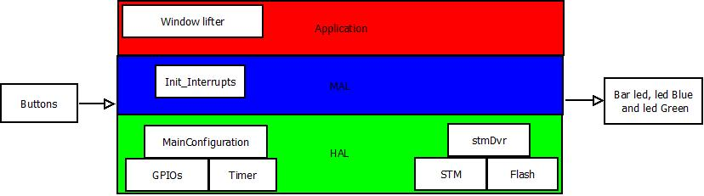

Fig. 4.1 Architecture Design of Window lifter.

The figure 4.1 show recourses that they are used in the different layers, in the HAL they are used GPIOs for inputs and output of buttons and leds, also Timer for counters, this provided delays to each transition of bar leds and also check how long time the button pressed. The STM is a peripheral to enable timer and interrupts, in this case used to generate a interrupt external that it´s anti pinch functionality, MAL provided drivers for control of hardware with application so that here initialized peripherals, interrupts, all to use.
For last Application should contain the functions for window lifter where decisions are made for functionality of each button.

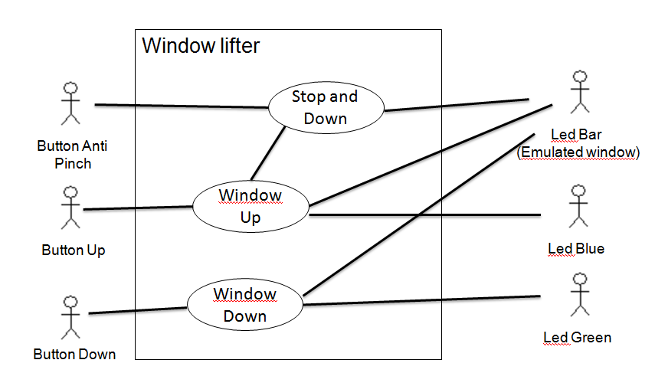

Fig. 4.2 Case Diagram
In the figure 4.2 show deeper interaction of inputs and outputs.

To control the inputs and outputs in the system in this case is the window lifter system is necessary to identify the components used hardware components were divided into external components in and out and internal components which are already in the layer of HAL in architecture design, and software components that are in the MAL and Application layers as shown in Figure 4.3, where you can observe the interaction and relationship of each component.

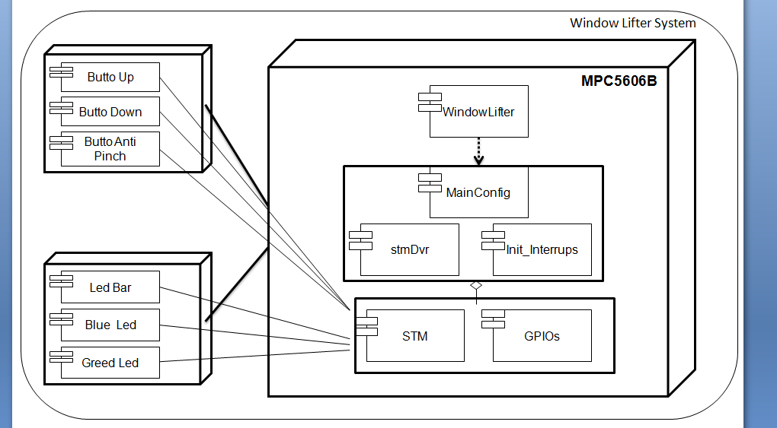

Fig. 4.3 Deployment and Component Diagram

The functions used are displayed in the diagram in Figure 4.4, which can be seen in more detail the functions to be implemented for the operation of the window lifter from configuration to application.

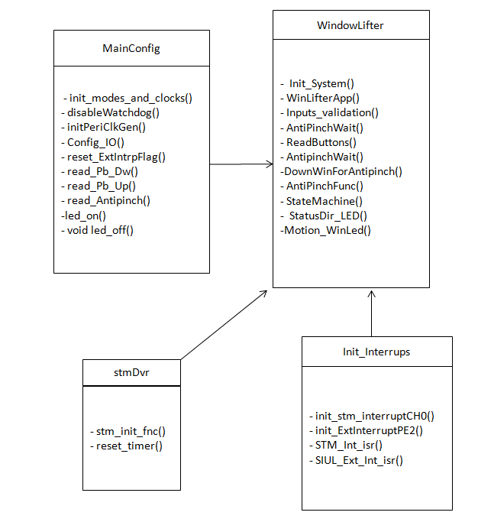

Fig. 4.4 Class Diagram

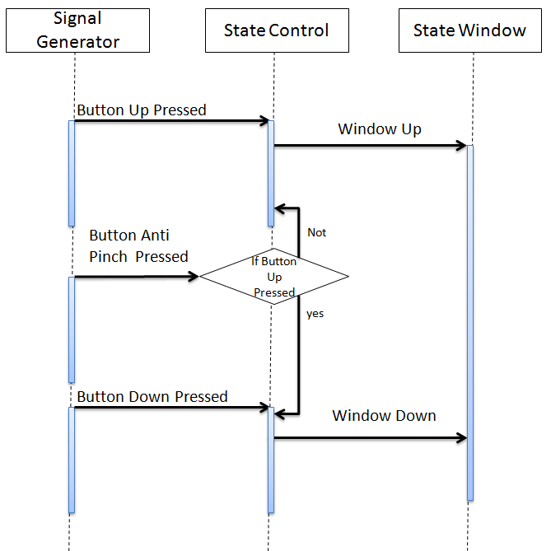

Fig. 4.5 Sequence Diagram

SW Component internal breakdown
For complex SW Components, the designer may define SW Subcomponents. Please consider also the work step "Deal with complexity" provided by the method for Detailed SW Design.
Note: SW Subcomponents are synonymous with the previous used term "Module"
Mapping to the file structure:
- Non complex SW Components should be represented by one object file.
- For complex SW Components each SW Subcomponent should be represented by one object file.
<Subcomponent decomposition if applicable>

Functional Decomposition
Overview of functions and their dependencies shown by a Static Function Tree
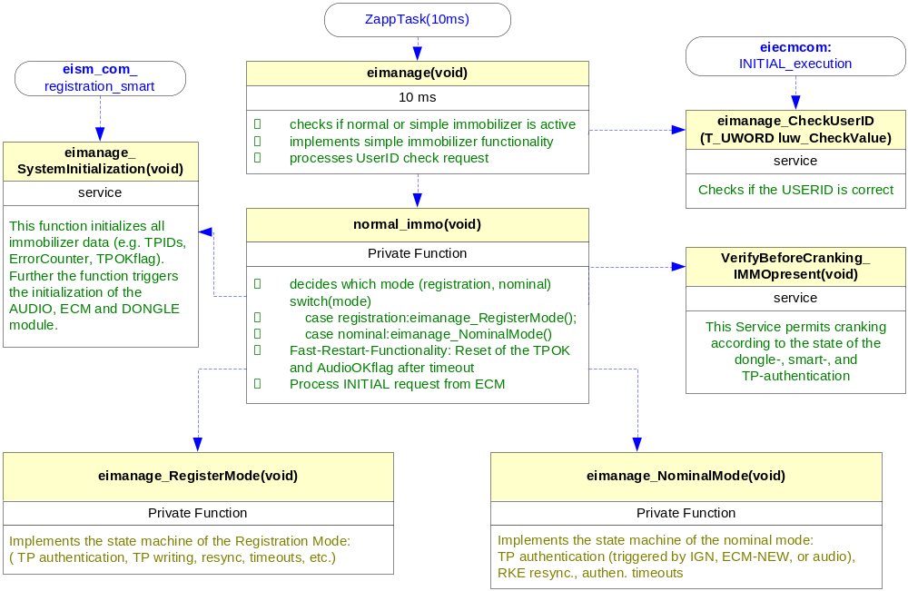
Function Description and Dynamic Behavior
Provide detailed static and dynamic description of all functions of the SW Component.
Functions which are defined in other SW Components shall only be referenced in the external interface description!
The signature description shall be done inside the function header in the source code.
For each function, the following section should be copied

Function <void> <Main> (void)

Description | Is the main function of the program
Parameter 1  <input > | void
Return Value | void
Precondition | Function main
Post condition | Initialization of the MCU
Error Conditions | -

Dynamic Behavior
Flow Chart

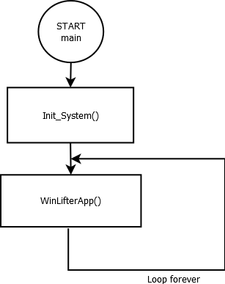

Function <void> <Init_System> (void)

Description | This function initializes the peripherals STM, GPIO and the Modes and clocks
Parameter 1  <input > | void
Return Value | void
Precondition | Function only is called at the begging of the program
Post condition | Enable the peripherals an set all the LEDs
Error Conditions | -

Dynamic Behavior
Flow Chart
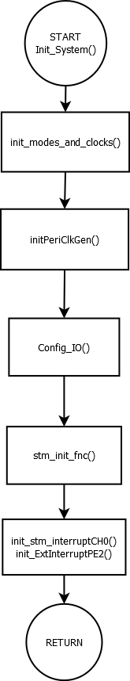

Function <void> <WinLifterApp> (void)

Description | This function is the application, and always get the information of the buttons and sets the LED bar
Parameter 1  <input> | void
Return Value | void
Precondition | The system has to be initialized
Post condition | Execution of the application
Error Conditions | -

Dynamic Behavior
Flow Chart

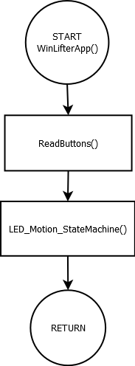

Function <void> <ReadButtons> (void)

Description | This function reads the buttons and change the global variable, rub_DirectionMove to indicate the direction of the movement and rub_ButtonPressed to indicate if a button has been pressed
Parameter 1  <input> | void
Return Value | void
Precondition | The system has to be initialized
Post condition | Modifications in the global variables:  rub_DirectionMove to indicate the direction of the movement rub_ButtonPressed to indicate if a button has been pressed
Error Conditions | -

Dynamic Behavior
Flow Chart
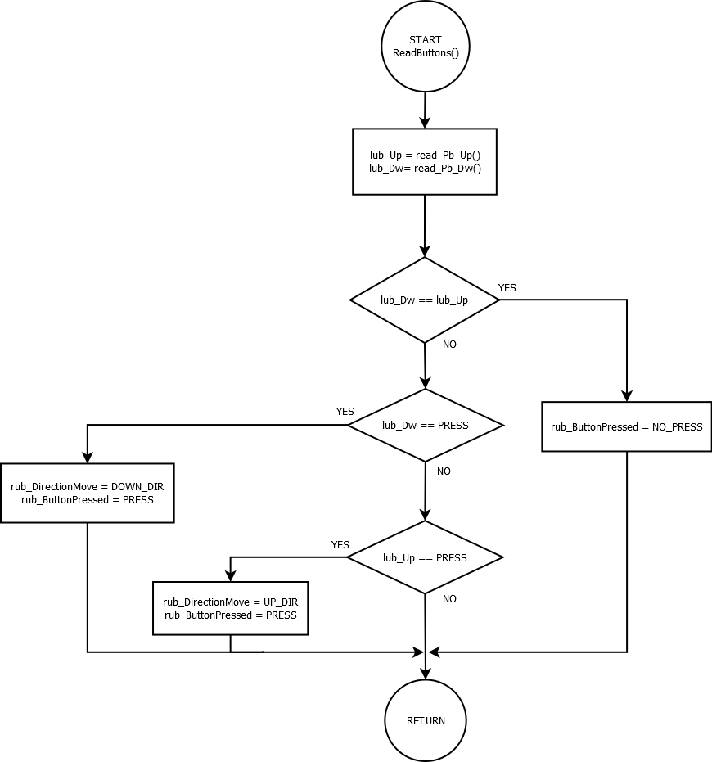

Function <void> <LED_Motion_StateMachine> (void)

Description | This function refreshes the status of the window into the LED bar
Parameter 1  <input> | void
Return Value | void
Precondition | The system has to be initialized and the variable rub_StateWin has to be a valid value
Post condition | The LED bar will be refreshed and will display the new value
Error Conditions | -

Dynamic Behavior
State Chart
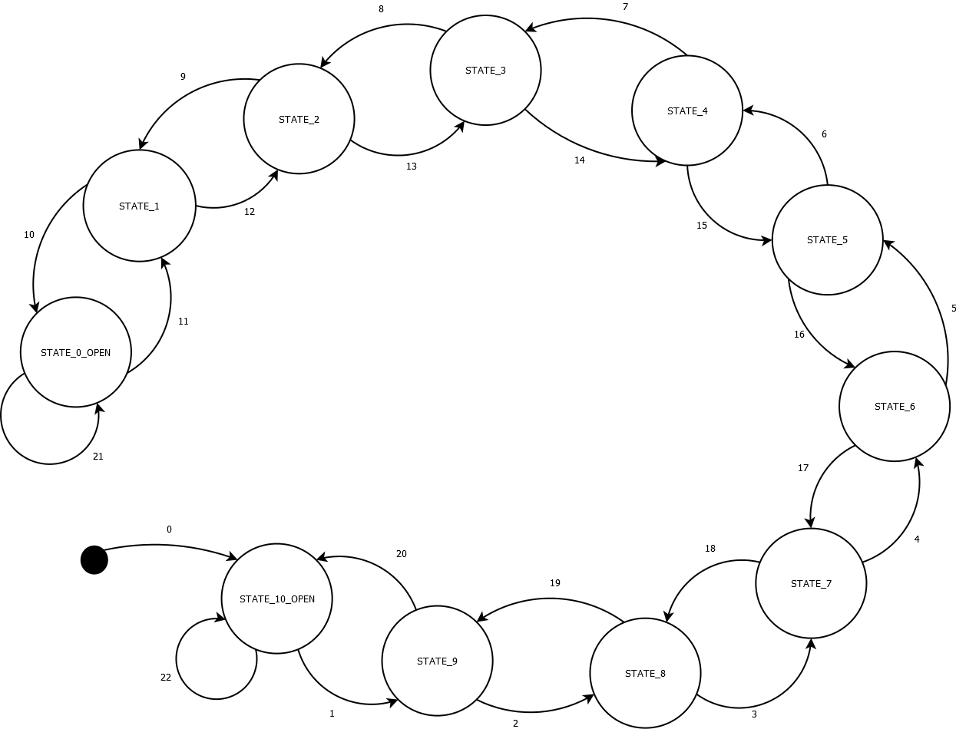

*for reference of translations see the table 1.1

Transition | Effect
0 | (Initial state) / rub_StateWin = STATE_10_CLOSE, led_on(1…10)
1 | rub_StateWin == STATE_9 / led_on(1…9), led_off(10)
2 | rub_StateWin == STATE_8 / led_on(1…8), led_off(9…10)
3 | rub_StateWin == STATE_7 / led_on(1…7), led_off(8…10)
4 | rub_StateWin == STATE_6 / led_on(1…6), led_off(7…10)
5 | rub_StateWin == STATE_5 / led_on(1…5), led_off(6…10)
6 | rub_StateWin == STATE_4 / led_on(1…4), led_off(5…10)
7 | rub_StateWin == STATE_3 / led_on(1…3), led_off(4…10)
8 | rub_StateWin == STATE_2 / led_on(1…2), led_off(3…10)
9 | rub_StateWin == STATE_1 / led_on(1), led_off(2…10)
10 | rub_StateWin == STATE_0_OPEN / led_off(1…10)
11 | rub_StateWin == STATE_1 / led_on(1), led_off(2…10)
12 | rub_StateWin == STATE_2 / led_on(1…2), led_off(3…10)
13 | rub_StateWin == STATE_3 / led_on(1…3), led_off(4…10)
14 | rub_StateWin == STATE_4 / led_on(1…4), led_off(5…10)
15 | rub_StateWin == STATE_5 / led_on(1…5), led_off(6…10)
16 | rub_StateWin == STATE_6 / led_on(1…6), led_off(7…10)
17 | rub_StateWin == STATE_7 / led_on(1…7), led_off(8…10)
18 | rub_StateWin == STATE_8 / led_on(1…8), led_off(9…10)
19 | rub_StateWin == STATE_9 / led_on(1…9), led_off(10)
20 | rub_StateWin == STATE_10_CLOSE / led_on(1…10)
21 | rub_StateWin < STATE_0_OPEN / STATE_0_OPEN, led_off(1…10)
22 | rub_StateWin > STATE_10_OPEN / STATE_10_CLOSE, led_on(1…10)

Table 1.1 Table of translations.

Function <void> <StatusDir_LED> (void)

Description | This function evaluates the variable lub_Direction to change the state of the LED_GREEN and LED_BLUE
Parameter 1  <input> | Enum T_DIRLED this parameter takes the next values ALL_OFF, BLUE_ON_UP and GREEN_ON_DW
Return Value | void
Precondition | This function must occur every valid press
Post condition | Modifications in the global variables:  rub_DirectionMove to indicate the direction of the movement rub_CmdWindow to indicate how much time the button has been pressed
Error Conditions | -

Dynamic Behavior
State Chart

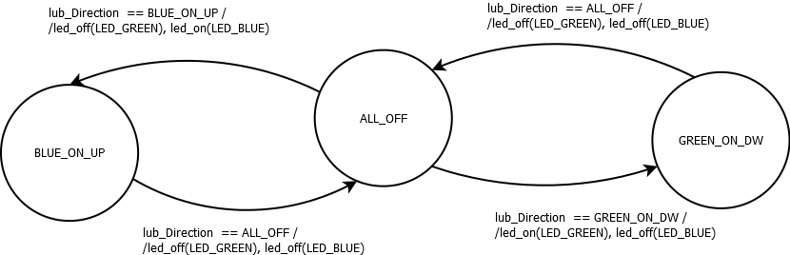

Function <void> <Motion_WinLed> (void)

Description | This function evaluates the conditions of a valid button press and change the value of rub_StateWin every 400 msec helped by the counter, rul_TimeTransition
Parameter 1  <input> | void
Return Value | void
Precondition | This function must occur every valid press
Post condition | Modifications in the global variables:  rub_StateWin that means a change in the state machine that control the LED bar.
Error Conditions | -

Dynamic Behavior
Flow Chart
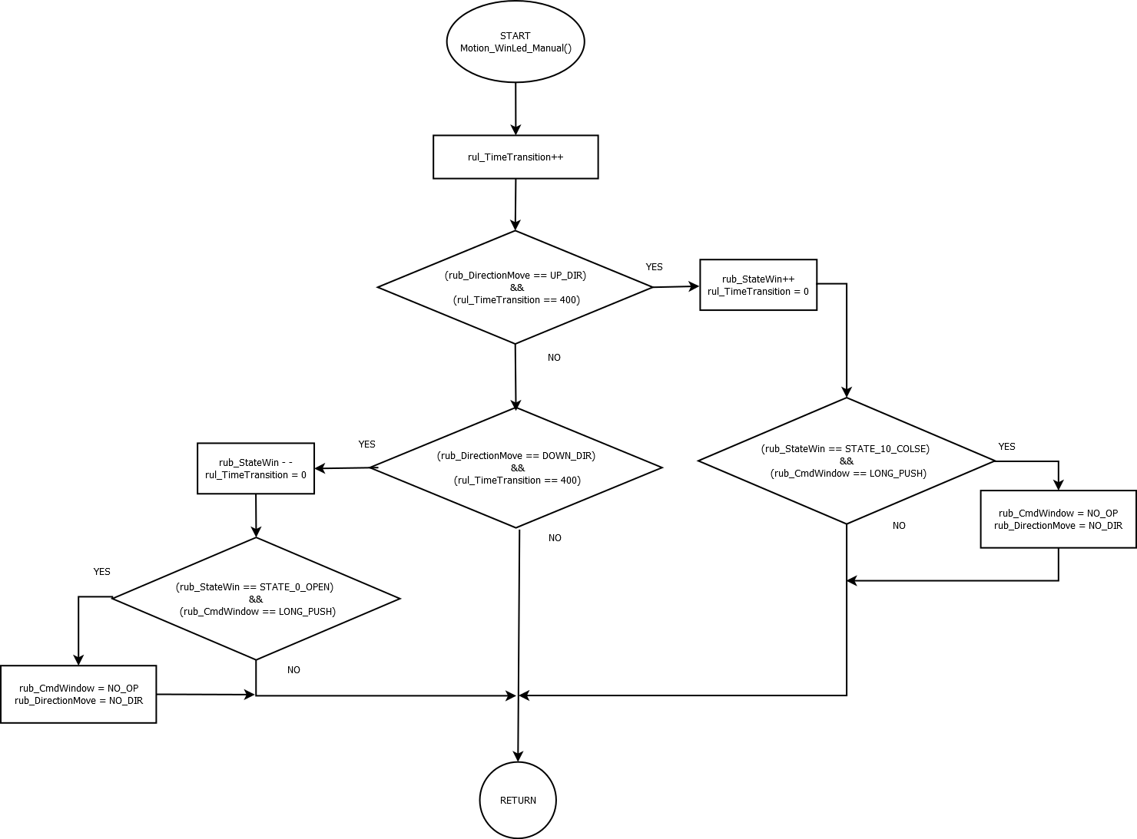

Function <void> <Inputs_validation> (void)

Description | This function validate if the button pressed the correct time, and modify the global variables rub_CmdWindow and rub_DirectionMove
Parameter 1  <input> | void
Return Value | void
Precondition | This function requires the call of an interrupt every millisecond
Post condition | Modifications in the global variables:  rub_DirectionMove to indicate the direction of the movement rub_CmdWindow to indicate how much time the button has been pressed
Error Conditions | -

Dynamic Behavior
Flow Chart

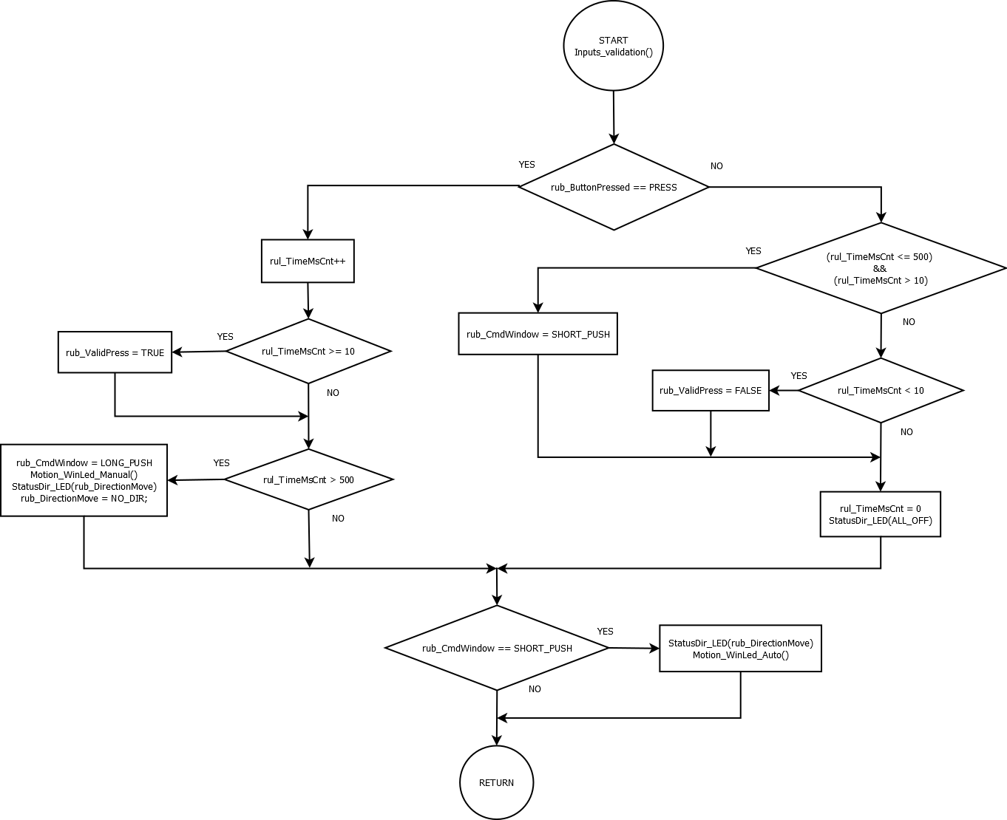

Function <void> <DownWinForAntipinch> (void)

Description | This function makes after a Antipich the LED bar goes down
Parameter 1  <input> | void
Return Value | void
Precondition | This function requires the call of an interrupt every time the antipinch button has been pressed and that signal must be a valid signal
Post condition | The LED bar will be totally turned off
Error Conditions | -

Dynamic Behavior
Flow Chart
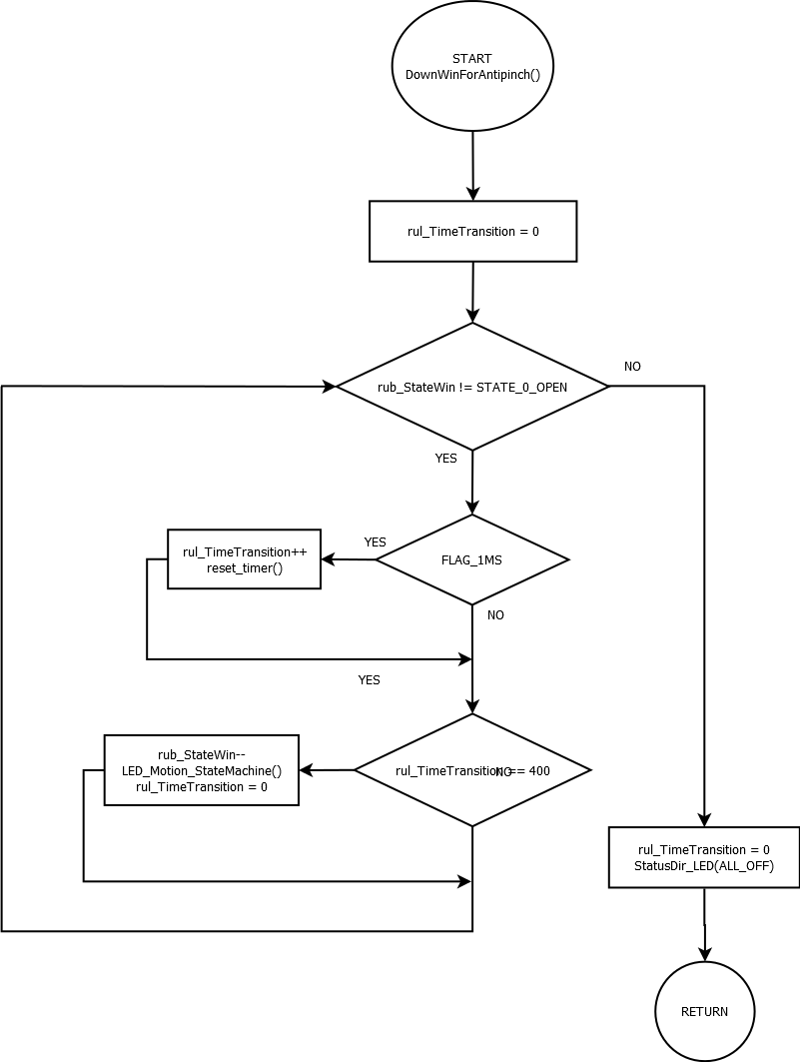

Function <void> <AntipinchWait> (void)

Description | This function makes the module must wait 5 seconds before admitting some other command.
Parameter 1  <input> | void
Return Value | void
Precondition | This function requires the call of an interrupt every time the antipinch button has been pressed, a signal from antipinch button valid and that the LED bar must be completely turned off
Post condition | The module will be available for new commands
Error Conditions | -

Dynamic Behavior
Flow Chart
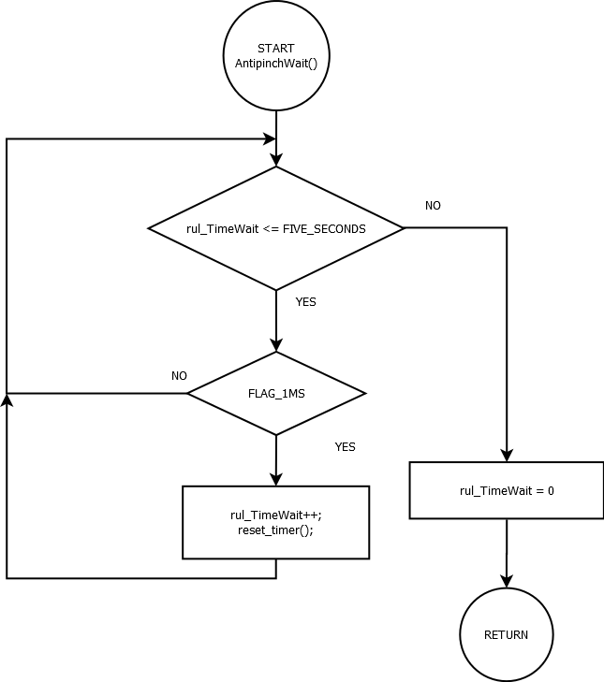

Function <void> <AntiPinchFunc> (void)

Description | This function evaluates if the antipinch has to occur and validates if that signal is valid
Parameter 1  <input> | void
Return Value | void
Precondition | This function requires the call of an interrupt every time the antipinch button has been pressed
Post condition | Modifications in the global variables:  rub_CmdWindow to indicate a change in the Bar LED  The bar LED must do a down movement and after that, the module must wait 5 seconds
Error Conditions | -

Dynamic Behavior
Flow Chart

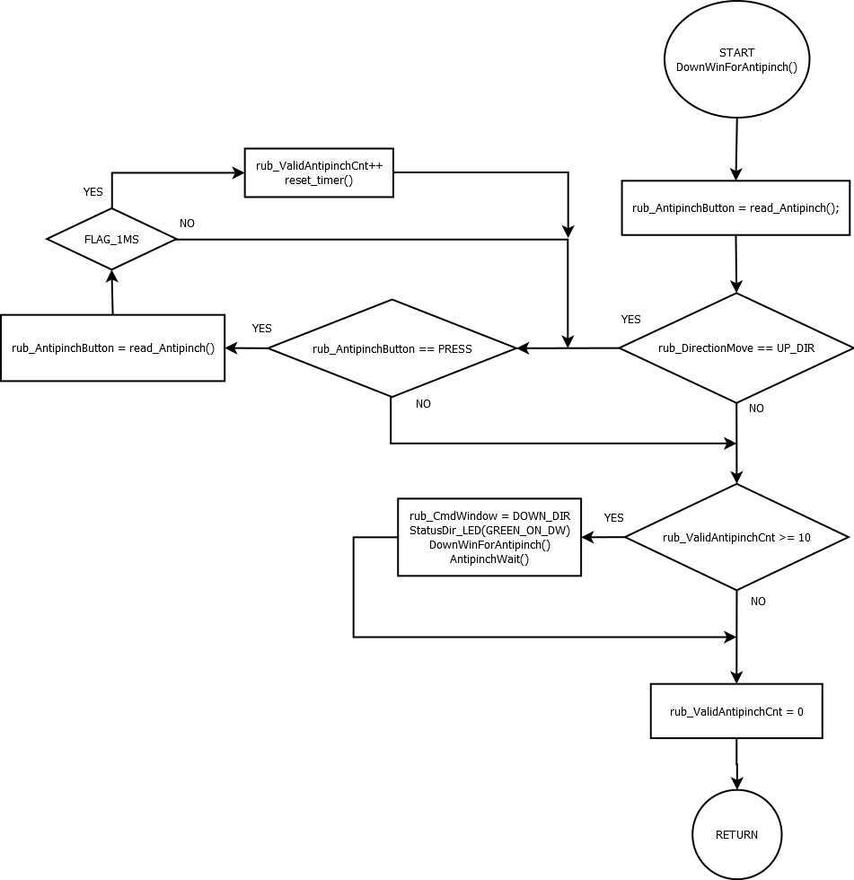

Function <void> <ISR> (void)

Description | This function have the interrupt service routines for counting time and for the antipinch button
Parameter 1  <input> | void
Return Value | void
Precondition | An interrupt occurs
Post condition | Modifies the global variables and the different functions that occurs in the module
Error Conditions | -

Dynamic Behavior
Flow Chart
